Pastor Derek Sanford: Author of UNTAPPED CHURCH and the Reinventing Church Podcast
www.dereksanford.com |FB – @pastordsanford | IG - @dereksanford | X - @dereksanford

The Untapped Potential Sitting All Around Us
Two Internal Roadblocks

- Staffing Shortage
UNTAPPED =
Available but not Used

- Demotivated Christians

God’s Design for Unleashing Every Believer’s Potential
3 Biblical Foundations

- Every Church is a BODY (1 Corinthians 12:4-7)

- Every Christian is a MINISTER (1 Peter 2:9)

- Every Leader is an Equipper (Eph 4:11-12)

Turning Potential into Kingdom Impact
6 Catalysts for Mobilizing Volunteer Leaders

- Pray Like Crazy
- Get Your Team Culture Right
- Identify Propellants and Obstructions
- Recruit Like You Mean It
- Blur the Lines Between Paid and Unpaid
- Do the Hard Work of People Development

INVITATION | CHALLENGE MATRIX
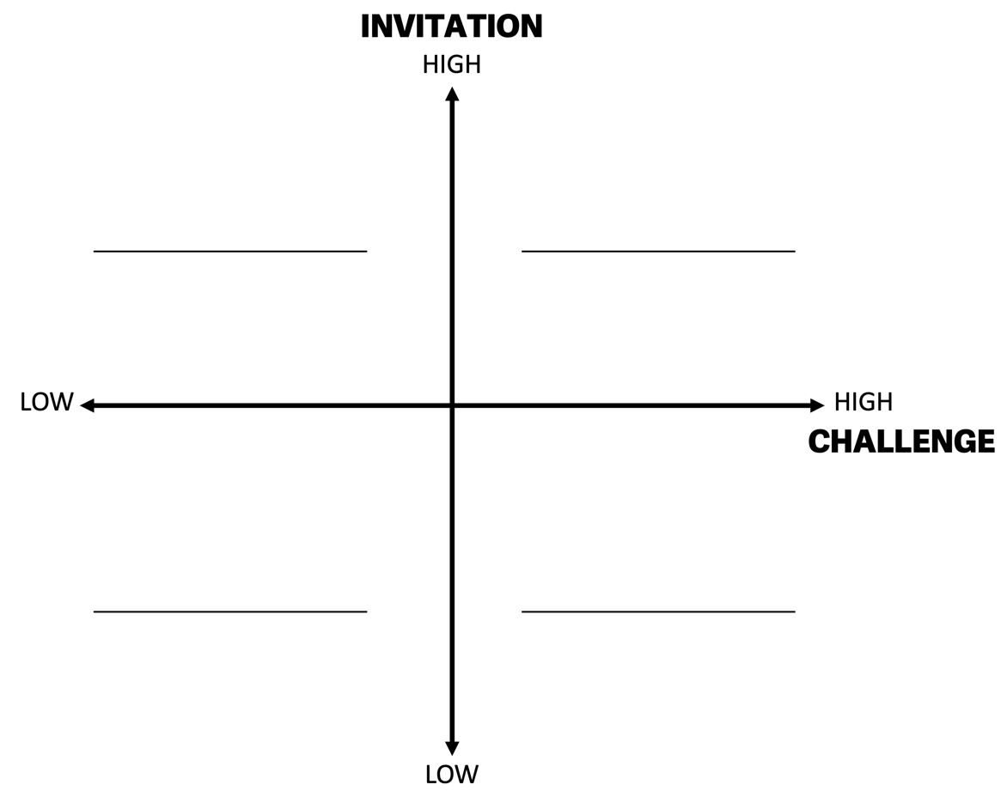

AN EMPOWERMENT MODEL:
TOWARD CONSTRUCTIVE LEADERSHIP BEHAVIOR

